SQL Learning Summary
PostgreSQL & DBeaver — Levels 0 through 8
On the Path to Becoming a Data Analyst
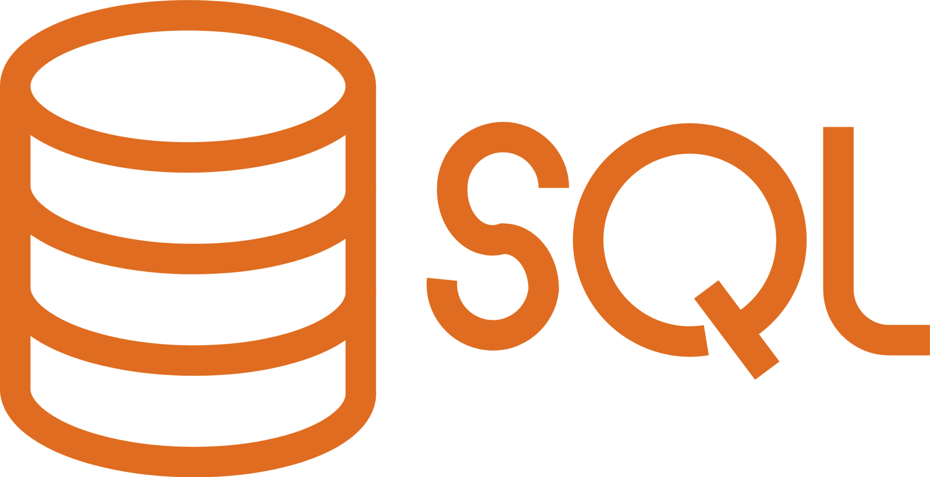

Table of Contents
• Level 0 — PostgreSQL & DBeaver
• Level 1 — SQL Fundamentals
• Level 2 — Data Aggregation
• Level 3 — SQL JOIN
• Level 4 — Intermediate PostgreSQL
• Level 5 — Window Functions
• Level 6 — SQL for Data Analytics
• Level 7 — PostgreSQL + Power BI/Tableau
• Level 8 — Portfolio Projects
• SQL Syntax Glossary

Level 0 — PostgreSQL & DBeaver
Basic concepts before writing queries.
- Database: a place to store structured data.
- DBMS: database management software (PostgreSQL is one type of DBMS).
- Relational Database: data is stored in tables that are linked to one another via keys.
- PostgreSQL vs. DBeaver: PostgreSQL = data storage engine (server); DBeaver = client application for executing SQL against PostgreSQL.
- Workflow: DBeaver sends an SQL query to PostgreSQL → PostgreSQL processes it → the results are sent back to DBeaver.
- Overall workflow: Excel/CSV → PostgreSQL → SQL → Power BI/Tableau → Business Insights.

Basic Operations
CREATE DATABASE database_name;
CREATE SCHEMA schema_name;
CREATE TABLE schema.table_name (
id_column SERIAL PRIMARY KEY,
text_column VARCHAR(100)
);
SELECT * FROM schema.table_name;
Import CSV: right-click the table in DBeaver → Import Data → select CSV → map columns → run.
Export query results to CSV: right-click the query results → Export result set → select CSV.

Level 1 — SQL Fundamentals
- Important data types: INTEGER/SERIAL, NUMERIC(p,s) for currency (not FLOAT), VARCHAR/TEXT, DATE/TIMESTAMP, BOOLEAN.
- Primary Key (PK): a unique identifier for each row. Foreign Key (FK): a column that references another table’s PK, forming a relationship.
- WHERE filters rows based on conditions; AND/OR/NOT combine conditions (AND is processed before OR—use parentheses to control the order).
- IN is used for multiple values at once; BETWEEN is used for ranges (inclusive).
- LIKE matches text patterns (case-sensitive in PostgreSQL); ILIKE is the case-insensitive version (PostgreSQL-specific). % represents any character, _ represents a single character.
- NULL means empty/no value — use IS NULL / IS NOT NULL, not '= NULL'.
- ORDER BY sorts the results (ASC/DESC); LIMIT restricts the number of rows.
- AS provides an alias; DISTINCT removes duplicates.
SELECT * FROM orders
WHERE (status = 'completed' OR status = 'pending')
AND amount BETWEEN 500000 AND 2000000
ORDER BY amount DESC
LIMIT 5;

Level 2 — Data Aggregation
- Aggregation functions: COUNT(), SUM(), AVG(), MIN(), MAX() — summarize multiple rows into a single number.
- COUNT(*) counts all rows; COUNT(column) ignores rows with NULL values in that column.
- GROUP BY groups rows for aggregation by category (like a Pivot Table).
- HAVING filters the results AFTER aggregation (unlike WHERE, which filters BEFORE aggregation).
- Logical execution order: FROM → WHERE → GROUP BY → HAVING → SELECT → ORDER BY → LIMIT.
- CASE WHEN creates conditional logic/categories (equivalent to IF/IFS in Excel).
- The pattern COUNT(CASE WHEN condition THEN 1 END) counts rows that meet a specific condition (other rows become NULL and are ignored by COUNT).
SELECT status, COUNT(*) AS count, SUM(amount) AS total
FROM orders
GROUP BY status
HAVING COUNT(*) > 1
ORDER BY total DESC;

Level 3 — SQL JOIN
- A JOIN combines rows from two tables based on related columns (PK-FK).
- INNER JOIN: only rows that match in both tables.
- LEFT JOIN: all rows from the left table, even if there are no matching rows on the right (the right-side columns become NULL). Useful for finding data that “has no match” (LEFT JOIN + WHERE ... IS NULL).
- RIGHT JOIN: the opposite of LEFT JOIN — rarely used in real-world applications.
- FULL OUTER JOIN: combines all rows from both tables, whether they match or not (not natively supported in MySQL).
- Self Join: Joins a table with itself (use different aliases and different ID conditions to avoid duplicates).
- IMPORTANT: JOINs on one-to-many relationships can DUPLICATE rows — be careful with SUM/aggregations on columns at a higher level than the fact table.
SELECT c.customer_name, o.order_id, o.amount
FROM customers c
LEFT JOIN orders o ON c.customer_id = o.customer_id
WHERE o.order_id IS NULL; -- customer has never placed an order

Level 4 — Intermediate PostgreSQL
- Subquery: a query within a query, the result of which is used by another query (in the WHERE or FROM clauses).
- CTE (WITH): a subquery named at the beginning, making long queries easier to read and reusable.
- UNION combines the results of two queries vertically and removes duplicates; UNION ALL includes all rows (faster).
- String functions: UPPER, LOWER, LENGTH, TRIM, CONCAT/||, SUBSTRING, REPLACE.
- Date functions: EXTRACT(part FROM date), DATE_TRUNC('unit', date) to round to the beginning of the period, TO_CHAR(date, format) to format as text.
- COALESCE(column, default) replaces NULL with the default value.
- CAST(value AS type) or the shortcut value::type for data type conversion (:: is specific to PostgreSQL).
- NULLIF(a, b) returns NULL if a = b — useful for preventing division by zero.
WITH monthly_revenue AS (
SELECT DATE_TRUNC('month', order_date) AS month, SUM(amount) AS total
FROM orders GROUP BY DATE_TRUNC('month', order_date)
)
SELECT TO_CHAR(month, 'YYYY Month') AS text_month, total
FROM monthly_revenue ORDER BY month;

Level 5 — Window Functions
- Window functions calculate aggregate values or rankings WITHOUT summarizing rows (unlike GROUP BY, which does summarize).
- Syntax: FUNCTION() OVER (PARTITION BY column ORDER BY column).
- PARTITION BY groups rows for window calculations (without reducing the number of result rows).
- ROW_NUMBER(): unique sequential number. RANK(): same rank for identical values; skips to the next number. DENSE_RANK(): same rank for identical values; does not skip.
- LAG()/LEAD(): retrieves the value from the previous/next row — used for month-over-month growth.
- SUM() OVER (ORDER BY column) without PARTITION BY produces a running total (cumulative).
- ROWS BETWEEN n PRECEDING AND CURRENT ROW for a moving average.
- SUM(SUM(column)) OVER () after GROUP BY produces a grand total without breaking the grouping — useful for calculating contribution percentages.
- Note: ORDER BY DESC in PostgreSQL places NULL values at the top by default (NULLS FIRST).
SELECT customer_id, order_id, amount,
RANK() OVER (PARTITION BY customer_id ORDER BY amount DESC) AS rank_per_customer,
SUM(amount) OVER (PARTITION BY customer_id) AS total_per_customer
FROM orders;

Level 6 — SQL for Data Analytics
A framework for translating business questions into queries:
Business Question → Required Data → Tables → JOIN? →
Aggregation? → SQL Query → Validation → Business Insight
- Aggregate ratios/margins (e.g., gross profit margin) must be calculated from the TOTAL that has been SUMmed, not the average ratio per row—because a simple average ignores the weight/contribution of each transaction.
- Columns that have already been pre-aggregated at a higher level (e.g., total_spent per customer) should not be SUM()ed again after JOINing to a more detailed table (one-to-many) — this will result in duplicate values.
- If calculated columns are already available and reliable in the data source, use them directly—do not recalculate them from raw components except for cross-validation.
- Use a combination of CASE WHEN and GROUP BY to create custom categories and then summarize them (segmentation).

Level 7 — PostgreSQL + Power BI/Tableau

PostgreSQL + Power BI Desktop
- Get Data → PostgreSQL database → Server: localhost, Database: database_name.
- Import mode (data is copied, faster) vs. DirectQuery (real-time, more limited)—for learning or portfolio purposes, use Import.
- Heavy/complex transformations should be done in SQL; light, report-specific data cleaning in Power Query; calculations requiring interactive dashboard context in DAX.
- You can use a custom SQL query as a direct data source (Advanced options when Get Data).

PostgreSQL + Tableau Public
- Tableau Public CANNOT connect live to a local database—you must export to CSV.
- Workflow: PostgreSQL → SQL Query → Export CSV → Import to Tableau Public → Dashboard → Publish.
- Data cleaning and JOIN operations should be completed in SQL before importing into Tableau, as Tableau Public works with static data (.hyper extracts).

Level 8 — Portfolio Projects

Project 1 — SQL Sales Analysis
Business questions addressed: summary KPIs (revenue, orders, AOV), monthly revenue trends + growth, top 10 best-selling products, top 10 customers, revenue by category, membership tier segmentation, revenue by city/region (2-level drill-down).

Project 2 — SQL Financial Analysis
Business questions addressed: summary of revenue/COGS/gross profit/margin, monthly margin trends, profitability by product, impact of refunds on net profit.
- COGS = cost_price × quantity; Gross Profit = Revenue − COGS; Gross Profit Margin = Gross Profit ÷ Revenue × 100%.
- To calculate the impact of refunds, only transactions with a “final” or “processed” status are counted as deductions from actual profit—“pending” or “rejected” statuses are not counted.

GitHub Portfolio Structure
project-name/
├── datasets/
├── sql/
│ ├── 01_setup_schema.sql
│ ├── 02_sales_analysis.sql
│ └── 03_financial_analysis.sql
├── screenshots/
├── dashboard/
└── README.md
README.md should ideally include: title & summary, business problem, dataset description, tools, database schema (ER diagram), key insights for each analysis (not just queries), and instructions on how to run the analysis. Do not include sensitive data or database credentials on GitHub.

SQL Syntax Glossary
Sorted alphabetically for quick reference.
Syntax / Functions | Usage
AND / OR / NOT | Combines or inverts conditions in the WHERE clause. AND is evaluated before OR—use parentheses to control the order.
AS | Assigns an alias or temporary name to a column or table.
AVG() | Aggregate function: calculates the average value.
BETWEEN a AND b | Filters a range of values, including both boundaries.
CASE WHEN ... THEN ... ELSE ... END | Conditional logic; creates new categories or labels.
CAST(x AS type) / x::type | Data type conversion. The :: syntax is specific to PostgreSQL.
COALESCE(column, default) | Replaces NULL with the default value.
COUNT() | Aggregate function: counts the number of rows. COUNT(*) counts all rows; COUNT(column) ignores NULL values.
CREATE DATABASE | Creates a new database on the PostgreSQL server.
CREATE SCHEMA | Creates a schema (a namespace for grouping tables) within the database.
CREATE TABLE ... REFERENCES | Creates a table; REFERENCES defines a foreign key to another table.
DATE_TRUNC('unit', date) | Rounds a date to the beginning of a period (e.g., the beginning of the month)—suitable for periodic reports.
DENSE_RANK() | Window function: ranking; identical values can have the same rank; does not skip to the next number.
DISTINCT | Displays only unique values/rows; removes duplicates.
EXTRACT(part FROM date) | Extracts a specific part of a date (YEAR, MONTH, DAY, etc.).
FULL OUTER JOIN | Displays all rows from both tables, whether they match or not.
GROUP BY | Groups rows to calculate aggregates per group.
HAVING | Filters the results AFTER aggregation (unlike WHERE, which filters before aggregation).
ILIKE | Like `LIKE` but case-insensitive. PostgreSQL-specific.
IN (value1, value2, ...) | Filters for a match with any one of the values in the list—a concise alternative to multiple OR clauses.
INNER JOIN | Combines only matching rows from both tables.
INSERT INTO ... VALUES | Adds a new row of data to a table.
IS NULL / IS NOT NULL | Checks whether a value is null or not null. You cannot use '= NULL'.
LAG() / LEAD() | Window functions: retrieves the value from the previous row (LAG) / next row (LEAD).
LEFT JOIN | All rows from the left table are displayed, even if there are no matching rows in the right table (NULL if none exist).
LIKE 'pattern' | Matches a text pattern. % = any number of characters, _ = one character. Case-sensitive in PostgreSQL.
LIMIT n | Limits the number of rows in the result.
MAX() / MIN() | Aggregate functions: largest / smallest value.
NULLIF(a, b) | Returns NULL if a equals b — prevents division by zero.
ORDER BY ... ASC/DESC | Sorts the results. Default is ASC (ascending).
OVER (PARTITION BY ... ORDER BY ...) | Defines a data 'window' for window functions, without aggregating the number of rows.
RANK() | Window function: ranking; identical values can have the same rank, skipping to the next number.
RIGHT JOIN | All rows from the right table are displayed, even if there are no matching rows in the left table.
ROUND(value, n) | Rounds a number to n decimal places.
ROW_NUMBER() | Window function: unique sequential number for each row, regardless of duplicate values.
SELECT ... FROM | Retrieves specific columns from a table.
SUM() | Aggregate function: sums values.
TO_CHAR(value, 'format') | Formats dates/numbers into text according to a specific pattern.
UNION / UNION ALL | Combines the results of two queries vertically. UNION removes duplicates; UNION ALL does not.
WHERE | Filters rows based on a condition; this is processed BEFORE aggregation or GROUP BY.
WITH ... AS (CTE) | Common Table Expression — a named subquery at the beginning of the query, making complex queries easier to read.

